Terraform:
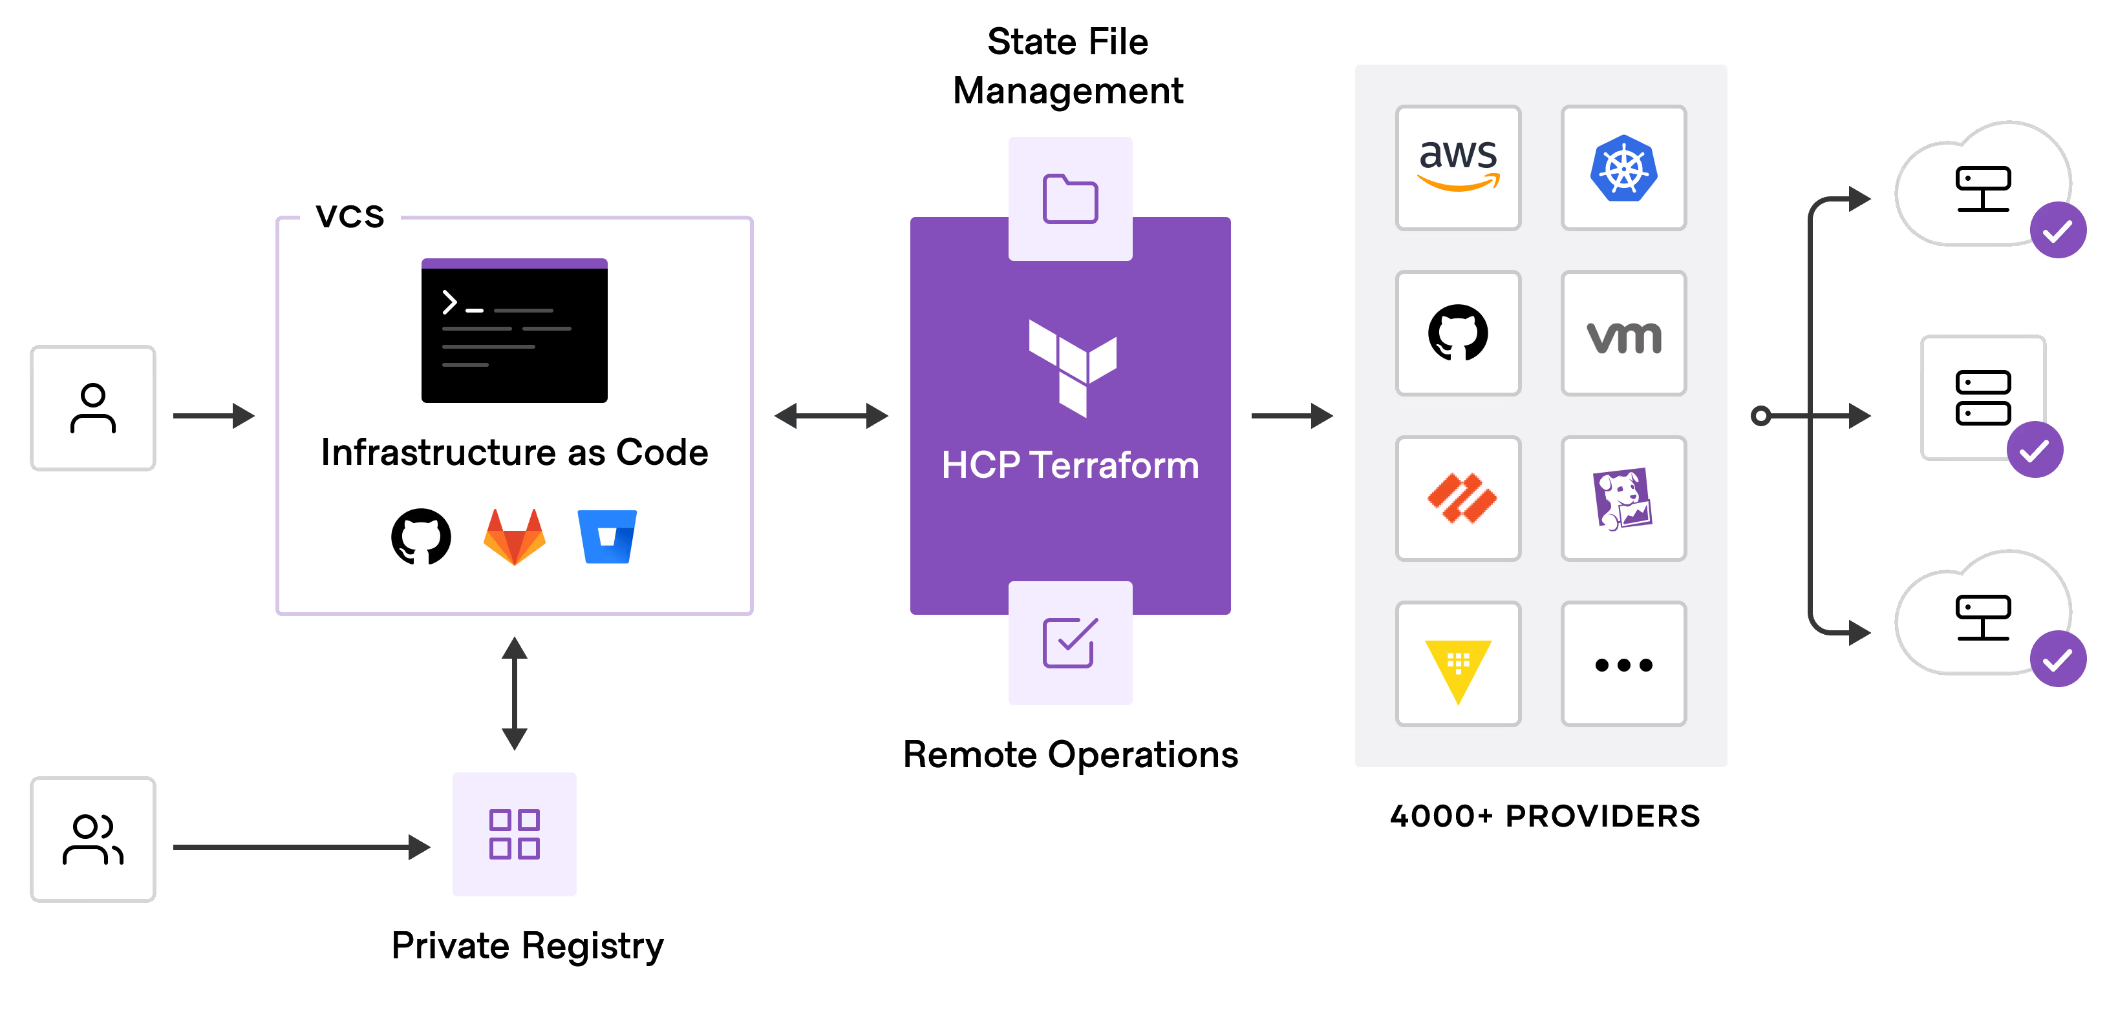
Terraform is a tool that helps you manage infrastructure (like servers and networks) using code instead of manually configuring them. You write simple, readable configuration files to define what your infrastructure should look like. With Terraform, you can automate changes to your infrastructure across different cloud providers, making the process consistent and reducing the chances of mistakes that can happen with manual setup.
Features of Terraform:
1. Enables users to define and manage infrastructure using version-controlled, human-readable configuration files.
2. Works with multiple cloud providers such as AWS, Azure, Google Cloud, and other platforms like Kubernetes.
3. Maintains a state file that tracks the infrastructure resources Terraform manages, allowing for smooth updates and destruction of resources.
4. Before applying any changes, Terraform provides a detailed execution plan that explains what it will do.
5. Automatically manages dependencies between resources and ensures the correct order of provisioning.
6. Supports the creation of reusable code blocks called modules to standardize and reuse infrastructure components.

POC Agenda:
Create infrastructure on cloud
VM / App service
Install required software like jdk, nodejs, npm etc on VM
Service account / S3 bucket
Service principal
Inbound / Outbound traffic management to VMs
Load balancer
Vault management
Etc….
Main commands:
init Prepare your working directory for other commands
validate Check whether the configuration is valid
plan Show changes required by the current configuration
apply Create or update infrastructure
destroy Destroy previously-created infrastructure

Terraform Workflow:
1. You write .tf configuration files using HCL to describe the desired infrastructure.
2. Run terraform init to intialize your working directory, download provider plugins, and set up the backend to manage the state.
3. Run terraform plan to preview the changes Terraform will make to achieve the desired state.
4. Run terraform apply to execute the changes defined in the configuration file and create the infrastructure.
5. After provisioning, you can update, modify, or destroy resources using terraform apply and terraform destroy.

Terraform Language:
A Terraform configuration can consist of multiple files and directories and the document is written in Terraform language that tells Terraform how to manage a given collection of infrastructure.

Syntax:

resource "aws_vpc" "main" {
cidr_block = var.base_cidr_block
}

<BLOCK TYPE> "<BLOCK LABEL>" "<BLOCK LABEL>" {
# Block body
<IDENTIFIER> = <EXPRESSION> # Argument
}

prerequisites:
Amazon Account, Terraform, Github, aws cli
1. Create Git repo
(NOTE: We are creating CI/CD pipelines using github Actions. Selecting runner ubuntu in that terraform create a statefile which is stored in runner)
2. Clone repo in the local system.
3. Terraform file types include:
main.tf – containing the resource blocks that define the resources to be created in the target cloud platform. (Create instance)
variables.tf – containing the variable declarations used in the resource blocks. (assign variable like instance_type)
provider.tf – containing the terraform block, provider configurations, and aliases.
backend.tf: s3 backend definition

README.md — As a general best practice, every repository should contain a README.md file that includes an overview of the source code, usage instructions, and any other relevant and important information
Automation scripts — When there is a need to include automation scripts (bash, shell, python, golang, etc.) in CI/CD workflow, when certain scripts are required to be executed on the target resource being created, or to build a source code, etc. Bash/shell scripts are very powerful in general; there are many reasons to use them.
YAMLs — The most common usage of YAML files in Terraform in this context is when implementing CI/CD automation.

Create main.tf > code for instance first >
Open Github repository in browser > Click on Settings > scroll down on the left side Find Security> Click on secret and variables
Set new ACCESS_KEY_ID (id YOU CAN FIND ON THE FILE DOWNLOADED WHILE CREATING ACCESS KEY )
Set new SECRET_ACCESS_KEY
Open aws console> sign in > on the right top corner (Click on profile) > select Security Credentials > create access key and download it.
Search Ec2 > Key pairs > create key pair (select rsa and .pem) download the file.
install aws cli :
in terminal:
aws configure
(put access_key, secret key, region where you want to create instance, s3 bucket(like: ap-southeast-1), format(json))
In aws console check instance is created.
Search S3 bucket in aws console > Create bucket with same region on ec2 instance

create backend.tf file: #S3 bucket configure
terraform {
backend "s3" {
bucket = "github-actions-demo-22" #bucket name
key = "github-actions-demo.tfstate" #statefile name
region = "ap-northeast-2"
}
}

create provider.tf file:
provider "aws" {
region = "ap-northeast-2"
}

For CI/CD pipeline go to the github repo in the browser: click on Actions tab
Configure Terraform Tab (if you want create file manually) follow the path:
in the directory create folder: .github/workflows/terraform.yml (configuration file in infrastructure as code)
Security group – Security groups act as virtual firewalls, controlling inbound and outbound traffic for associated VPC resources like EC2 instances.

# Define a security group with SSH access
resource "aws_security_group" "allow_ssh" {
name = "allow_ssh"
description = "Allow SSH access from anywhere"

ingress {
from_port = 22
to_port = 22
protocol = "tcp"
cidr_blocks = ["0.0.0.0/0"] # Allows SSH from any IP address
}

egress {
from_port = 0
to_port = 0
protocol = "-1"
cidr_blocks = ["0.0.0.0/0"] # Allows all outbound traffic
}
}

In instance:
resource "aws_instance" "web" {
ami = data.aws_ami.ubuntu.id
instance_type = "t2.micro" #user input
key_name = "l2"
security_groups = [aws_security_group.allow_ssh.name] # Attach the security group here

To install Software:
resource "aws_instance" "web" {
ami = data.aws_ami.ubuntu.id
instance_type = "t2.micro" #user input
key_name = "l2"
security_groups = [aws_security_group.allow_ssh.name] # Attach the security group here

user_data = <<-EOF
#!/bin/bash
# Update and upgrade the system
sudo apt update -y && sudo apt upgrade -y

# Install Java Development Kit (JDK)
sudo apt install openjdk-11-jdk -y

# Install Node.js and npm
curl -fsSL https://deb.nodesource.com/setup_18.x | sudo -E bash -
sudo apt install -y nodejs

# Verify installations
java -version
node -v
npm -v
EOF

tags = {
Name = "Hello"
}
}

